Executive Board Members  Alina Rodriguez  President  Lourdes Fuller  President Elect  Mark Rosenkratz  Secretary  Treasurer  Lissette Lutz  Past President  Marlon Zuniga  Committee Members  Corresponding Secretary  Zahra Farooq  Graphic Designer  Nadyia Duff  Hospitality Chair  Marlene Kohn  Hospitality Chair Assistant  Beth Goldstein  Merchandise Chair  Pat Tuttle  Website Chair  Joanne Baquedano  Social Media Chair  Susan Feliciano  Professional Development Chair  Susan Feliciano  Membership Chair  Susie Blair  Zahra Farooq  New Teacher/ Mentoring Chair  Nadia Earl  Lissette Lutz  Photography/ Social Media Chair  Susan Feliciano  Teacher Exhibitions Chair  Peter de Mercado  Teacher Awards Chair  Mabel Morales  Nadia Earl  F4DAE Chairs  Marilyn Traeger & Marlene Kohn  Advocacy Chair  Mark Rosenkrantz  Historical Awards Advisory Chair  Mabel Morales  Retired Teachers Chairs (RATs)  Pat Tuttle/ Marilyn Traeger | 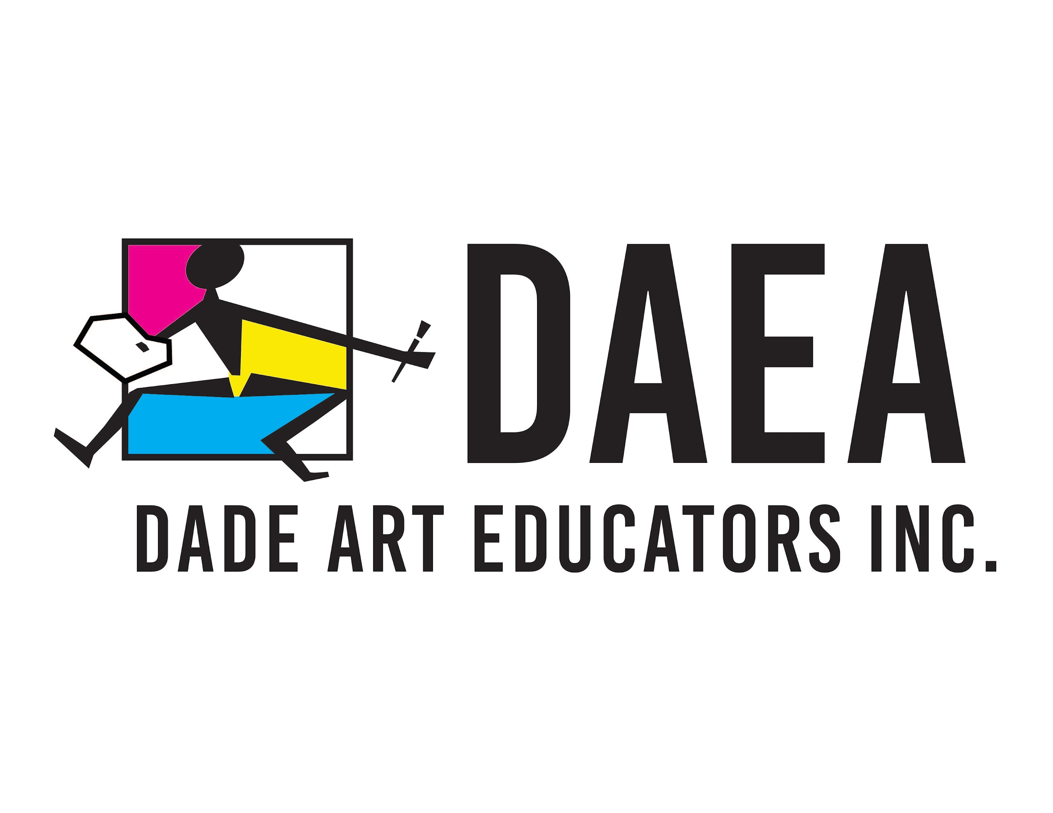  Dear Art Educators and Patrons:  On this sultry Miami summer afternoon, I welcome you back to a new school year on behalf of DAEA.  I felt nostalgic as I came across a 32-page publication from DAEA dated 1977. The copies of D’Art were well preserved by my first mentor from 1989, Dr. Susan Mussoline. Names on the typeset revealed some of the past magic stars of art education, from the late Jacqueline Hinchey, Betsy Kaplan, and Dr. Clem Pennington, to Dianne Greaney and others too numerous to mention. D’Art was published three times a year and recounted newsworthy events across the county, art awards, teacher and student scholarships, and interviews with national, state, and community leaders on the state of art education. The publication team was composed of individual art teachers and volunteers like you, whose direct involvement and participation have always been essential to making “real” changes in art education.  Looking back helps us plan for the future. What was true in 1977 is also a verity today; a small percentage of active art teachers make that personal commitment to their local art teacher organization. It is understandable as many teachers face large teaching loads and other hardships. DAEA is blessed with a small group of retired art teachers who are devoted to the organization and are always there for you. What if we were to join forces, mobilize, and advocate for our art programs and art education? I am sure the tide will shift in our favor if we work in unity.  No man is an island entirely in itself; every man is a piece of the continent, a part of the main.  John Donne  I invite you to be a shining star, a collaborator, make new connections with your colleagues, and get out of the silos of your classroom. Act immediately, and join DAEA. This 2022-23 school year will be one to remember and my last as president of this organization. I predict your 100% commitment and those of all the art teachers this school year. Let’s make magic together!  Alina Rodriguez  Sincerely,  Alina Rodriguez  President  Dade Art Educators Association, Inc.  cc: Mabel Morales, District Supervisor, Visual and Performing Arts  D.A.E.A. Executive Board Members
