Executive Board Members  Alina Rodriguez  President  President Elect  Secretary  Treasurer  Lissette Lutz  Past President  Marlon Zuniga  Committee Members  Corresponding Secretary  Zahra Farooq  Membership Chair  Susie Blair  Exhibitions Chair  Peter de Mercado  Hospitality Chair  Marlene Kohn  Merchandise Chair  Pat Tuttle  Website Chair  Joanne Baquedano  Social Events Chair  Professional Development Chair  Gonzalo Battaglia  New Teacher/ Mentoring Chair  Photography/ Social Media Chair  Susan Feliciano  Graphic Designer  Joanne Baquedano  Awards Chair  Mabel Morales  F4DAE Chairs  Marilyn Traeger & Marlene Kohn  Advocacy Chair  Historical Awards Advisory Chair  Dr. Clem Pennington  Retired Teachers Chairs (RATs)  Charles Gaffney | 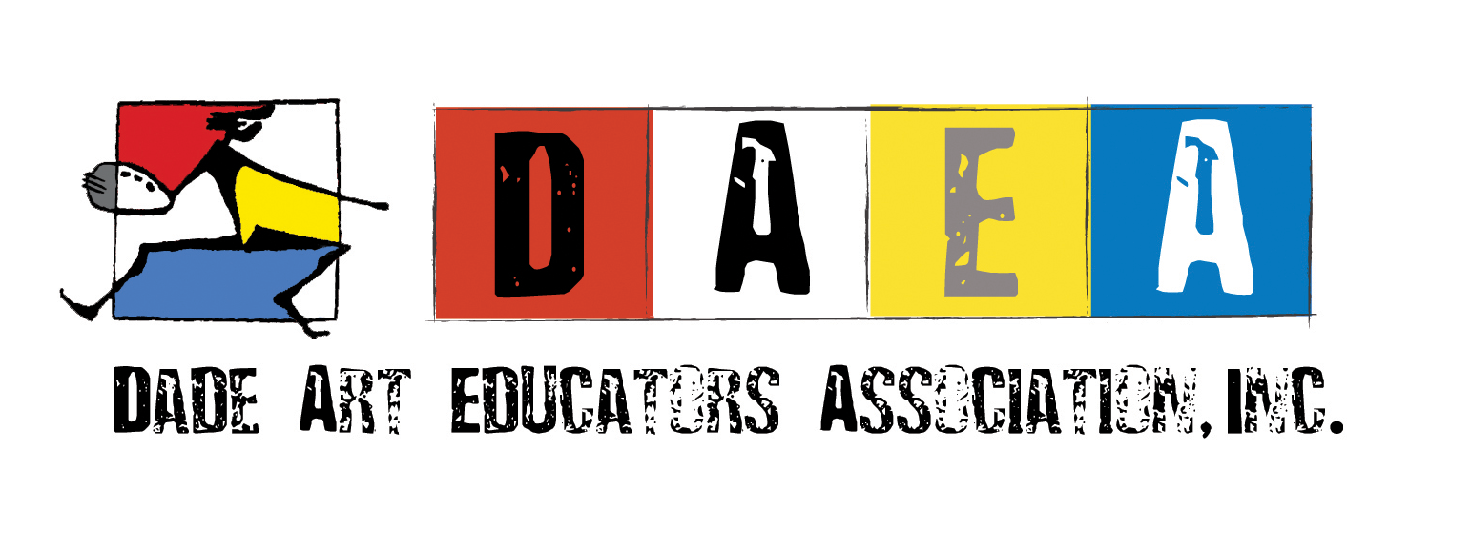  08/06/2021  Dear Art Educators:  Art is your SUPERPOWER is the theme for the opening of this school year’s kick-off event for art teachers on Thursday, August 19, 2021. As the new president of the Dade Art Educators Association (DAEA), I want to invite you to join our DAEA superheroes.  Each of you has a superpower and that is your genius. We need your skills, talent, leadership qualities, and unique perspective to make amazing things happen this school year! Our goal is to offer more student and teacher scholarships, increase free professional development and open it to charter, private school art teachers, host 3 major art exhibitions, start a blog post to advocate for the arts, add a yearly grant for three art teachers to attend a summer art retreat, and continue providing annual teacher awards. All these benefits are only available to our members.  If there is one thing the pandemic has taught us is that we need each other and that teamwork, collaboration, and service work are essential. Here are a few ways you can help to contribute to our goals:  - Become a DAEA member.  - Volunteer to serve on our board or nominate someone.  - Participate in our free workshops or volunteer to teach a workshop.  - Participate in one or more of our three curated art shows either as an artist, curator, installer, or promoter.  - Advocate for the arts by sharing the work you do with your students in a blog post. Be a writer, editor, or photographer for the blog.  - Volunteer to help organize our annual awards ceremony at PAMM, and at the FAEA Conference.  - Attend DAEA meetings which will happen 3 times a year.  - Assist at the student shows working at the DAEA table to help promote the arts.  - Assist the membership chair by reaching out to new members.  https://fi-fi.facebook.com/theartofed/videos/4111092598979639/  You enhance everything you touch with super creative power; you are a supersonic beacon for young curious minds. Help DAEA make artistic magic that transforms teachers into heroes and students into innovative thinkers and problem-solvers.  Sincerely,  Alina Rodriguez  President  Dade Art Educators Association, Inc.  cc: M-DCPS School Board Members  Mabel Morales, District Supervisor, Visual and Performing Arts  D.A.E.A. Executive Board Member

